**The collapse of a keystone forage species**

Buren, A.D.1*§, Murphy, H.M.1§, Adamack, A.T.1, Davoren, G. K.2, Koen-Alonso, M.1, Montevecchi W.A.3, Mowbray, F. K.1, Pepin, P.1, Regular, P.1, Robert, D.4, Rose, G.A.5, Stenson, G.1, Varkey, D.1

Affiliations:

1. Northwest Atlantic Fisheries Centre, Fisheries and Oceans Canada, St. John's, NL, Canada

2. Department of Biological Sciences, University of Manitoba, Winnipeg, MB, Canada

3. Cognitive and Behavioural Ecology Progamme, Departments of Biology and Psychology, Memorial University of Newfoundland, St. John’s, NL, Canada

4. Institut des sciences de la mer, Université du Québec à Rimouski, Rimouski, QC, Canada

5. Institute for the Oceans and Fisheries, UBC, Vancouver, Canada.

*corresponding author: Tel: +1 709 772 4049; Fax: + 1 709 772 4138; e-mail: Alejandro.Buren@dfo-mpo.gc.ca

§ A.D.B and H.M.M. contributed equally to this paper and others have contributed equally. Authors have been listed in alphabetical order for each contribution level.

**Methods**

To test the hypotheses of collapse and non-collapse of the capelin stock in NAFO Div. 2J3KL (hereafter Div. 2J3KL), we applied the weight of evidence approach using multiple, independent data sets and diverse statistical methods (e.g., triangulation, sensu Munafò & Davey Smith 2018). To do this, we constructed our paper based on Frank et al. (2016) (hereafter Frank et al.), which recently reviewed the literature on the Northwestern Atlantic ecosystem response to the regime shift in 1991 and found support for the non-collapse hypothesis with capelin hypothesized to be non-migratory post-1991. This conclusion is in contrast with research indicating that the regime shift in the early 1990s was associated with an abrupt and persistent decline in capelin (Miller 1994, 1997, Rose 2007, DFO 2008, 2010, 2013, Buren et al. 2014, DFO 2015). Each section of this review opens with a statement of the main conclusion(s) from the analyses presented in Frank et al. and the counter-argument in the primary and government literature. In some sections, new data and analyses were used to test the main hypotheses. Each section concludes with an evaluation of the data in support of each hypothesis. Once this approach was completed for all sections, the weight of evidence approach was used to determine which hypothesis was best supported by the independent data sets, analyses, and reviewed literature.

## CAPELIN

### Offshore capelin distribution: acoustic surveys

Frank et al. contended that Canada and the USSR offshore acoustic surveys found low capelin biomasses in the fall of 1991 and 1992 because capelin became non-migratory in the fall of 1990 in Div. 2J3K. Alternatively, the fall acoustic surveys detected a real and sudden decrease in capelin biomass in Div. 2J3K in 1990 (e.g., Miller 1991, 1992, 1993, 1994, Bakanev 1992, Mowbray 2014). From 1982 to 1992, Canada conducted fall (October) acoustic surveys for capelin in Div. 2J3KL (Mowbray 2014). The fall acoustic surveys targeted the maturing portion of the stock during winter feeding migrations to provide estimates of the size and number of maturing fish being recruited to the fishery the following year (Mowbray 2014). The capelin stock in Div. 2J3KL was also acoustically surveyed by the former USSR in November from 1972-1992 although the USSR acoustic survey covered a more restricted geographic area compared to the Canadian acoustic survey as it did not go as far into the inshore area (Bakanev 1992; Fig. 1). The USSR fall acoustic surveys were conducted after the Canadian surveys and consistently estimated higher capelin abundances, which may have been due to timing, as capelin cease feeding in November and aggregate into large overwintering shoals (Winters 1995). In 1990, the Canadian fall acoustic survey estimated a very low capelin biomass while the USSR acoustic survey estimated the smallest biomass since 1984 (Winters 1995). Both the USSR and Canadian acoustic surveys estimated record low biomasses in the fall of 1991 and 1992 (Winters 1995). The decrease in capelin biomass in both surveys corresponded with very few capelin surveyed off the coast of Labrador and a southern shift in stock distribution to southern Div. 3K and northern Div. 3L (Miller 1991,1992). A Canadian expanded fall survey (Div. 2J3KL) in 1993-94 was conducted to determine if the ‘missing’ capelin could be located. However, the expanded fall acoustic survey confirmed the results of the 1991-92 fall surveys of a low capelin biomass and a southern distribution of the stock (Miller 1994, 1995). The fall acoustic survey was terminated in 1995.

High densities of overwintering mature capelin as well as large schools of immature capelin in seasonal surveys conducted in Trinity Bay in 1967-68 (Winters 1970) were used by Frank et al. to support the hypothesis of a non-migratory capelin stock post-1991 by suggesting that capelin can inhabit inshore areas year round. Seasonal acoustic surveys (January, June and September) were conducted in Trinity Bay by Fisheries and Oceans Canada from 2003-05 to test the hypothesis of year round residency of capelin in the inshore (Fig. 2 a,b; see supplementary section for details on methods). There was considerable seasonal consistency in annual trends in capelin age composition for these three years. In January, ~ 50% of the overwintering fish were age-1 (Fig 3 a). The relative contribution of older, maturing fish increased through the spring with peak abundances observed in June as maturing fish migrated into Trinity Bay (Fig 3 b). By September, nearly all maturing and post-spawning capelin had left Trinity Bay and age-1 fish again dominated the catch (Fig. 3 a,b). Seasonally, the maximum mean density of capelin observed in Trinity Bay was 10,000 kg / km2 in June, which corresponded with the start of the spawning period when capelin were highly aggregated inshore (Fig. 2 b). In addition to the 3-year seasonal acoustic survey in Trinity Bay, the annual spring offshore acoustic survey in Div. 3L has included an acoustic survey of Trinity Bay since 1999 (except for 2006, 2014-16) (Fig. 2 b). Capelin biomass in May in Trinity Bay was lower than in the June seasonal surveys (Fig. 2 b), and the capelin biomass in Trinity Bay in May was lower than the offshore biomass estimates except in 2001 and 2010 when the biomass in Trinity Bay was similar to the offshore (Fig. 4).

In summary, while the fall acoustic surveys in Div. 2J3KL cannot refute the hypothesis that capelin are non-migratory post-1991 as the inshore areas were not surveyed, the lack of significant aggregations of adult capelin outside of the peak spawning period during seasonal acoustic surveys and annual May acoustic surveys in Trinity Bay does support the hypothesis of a collapse of the capelin stock post-1991. Furthermore, capelin stocks in other regions did not become non-migratory in response to changes in stock abundance and environmental conditions but rather demonstrated changes in spatial distribution and migration routes (Olafsdottir & Rose 2012, Carscadden et al. 2013), and these changes were best documented for the fall feeding periods of these stocks (Ingvaldsen & Gjøsæter 2013).

### Offshore capelin distribution: annual multi-species bottom-trawl surveys

(Frank et al. 2016) hypothesized that there was an abrupt change in capelin migration patterns post-1991, with capelin now remaining inshore year round. The fall bottom trawl survey (FBTS) data were used to point to a westerly, inshore shift in the center of capelin concentration in 1996-2010 compared to 1985-1995 (Frank et al. 2016). Alternatively, bottom-trawl survey data of pelagic fish should be used with caution due to catchability of trawl gear and behavior of pelagic fishes (e.g., Jech and Quinn 2016).

Frank et al.’s annual mapping of the centre of concentration of capelin using the FBTS presence/absence data demonstrates the high degree of inter-annual variability in capelin abundance within the earlier period (1985-1995), with inshore distributions occurring in three high abundance years (1986-1988, Fig S2 in Frank et al. 2016). This variability is likely related to the poor catchability of capelin in the Engel otter trawl used in the FBTS from 1985-1995. A similar centre of gravity analysis using FBTS data post-1995 showed a southerly shift in distribution with a recent shift to the northwest in 2011-14 (DFO 2015). Neither of these analyses accounted for inter-annual changes in spatial distribution due to FBTS sampling effort.

To test the hypothesis of an inshore centre of distribution of capelin post-1991, we used the center of gravity approach described in (Thorson et al. 2016). Specifically, the VAST package in R (Thorson & Barnett 2017) was used to fit a geostatistical delta-generalized linear mixed model to estimate the spatial and temporal distribution of capelin. The main advantages of this approach is that it accounts for changes in the spatial distribution of sampling effort from one year to the next and provides a means of estimating the standard error of the center of gravity metric, which provides a perspective on the significance of distributional shifts. Like DFO (2015), we excluded the 1985-1995 period from our analysis and focused on the post-1995 period when the catchability of capelin improved with the use of a Campelen 1800 shrimp trawl. Our geostatistical analysis did not support the hypothesis that capelin shifted their distribution towards the inshore post-1995 and there is no evidence of an easterly or westerly movement in the center of gravity of capelin (Fig. 5). Instead, the center of gravity of capelin remains > 100 km offshore and demonstrates pronounced shifts in the north-south dimension (Fig. 5).

Other analyses using the FBTS data indicate that it is unrealistic to assume that the 3 to 6 Mt of capelin that are ‘missing’ in the offshore surveys are now residing in the inshore. The inshore strata are inconsistently covered by the annual FBTS and an area of ~35,000 to ~71,000 km2 remains unsurveyed each year. The minimum density of 3 to 6 Mt of capelin in these inshore waters would have to be between ~41,000 to ~170,000 kg / km2, uniformly distributed throughout the unsurveyed area. The maximum mean density of capelin observed in the Trinity Bay survey strata in June was 10,000 kg / km2 (Fig. 2 b). Maximum mean density of capelin observed outside the spawning period was only 40 kg / km2 (Fig. x). Neither observation can account for the required amount of capelin hypothesized to be residing inshore if there was no collapse of capelin in the NL region.

In summary, recognizing the bias in catchability of pelagic fish in the Engels (1978-1994) vs Campelen (1995-2017) trawls, we only used FBTS data from 1995 onwards, which precludes the FBTS centre of gravity analysis from providing support for the non-collapse hypothesis. We also acknowledge that FBTS data is not an accurate method to survey pelagic fish, as outlined succinctly in Jech and Quinn (2016). When we look at other sources of capelin distribution data during this time period (sensu Jech and Quinn 2016) the juvenile capelin surveys sampled with IGYPT trawls in the northeastern bays and the offshore from 1994-1999 also found a southward distribution of capelin juveniles compared to the 1980s with centers of distribution on the northern Grand Bank and along the northeast coast, but not in the bays, of Newfoundland (Anderson et al. 2002). These two independent datasets suggest that capelin are not residing in the bays of Newfoundland post-1991.

**Capelin depth distributions during offshore acoustic surveys in Div. 3L**

Frank et al. does not use the change in capelin diel vertical migrations (DVM) post-1991 to support or refute the capelin collapse hypothesis. However, Frank et al. (2005, 2013) used the day-to-night catch ratio of Atlantic herring and sand lance captured in the bottom trawl surveys to argue that the pelagic outburst on the eastern Scotian shelf was ‘real’ and was not an artifact of a change in pelagic fish behavior post-cod collapse (McQuinn 2009). The change in capelin DVM post-1991 required dedicated experiments in 1995 and 1999 to address the potential impact of DVM changes on the availability of capelin to the acoustic surveys (Mowbray 2002). The proportion of capelin biomass in the trawl zone (bottom 4 m of the water column) increased post-1991 (Mowbray 2002), likely a response to a decline in the risk of Atlantic cod predation that may drive capelin into the pelagic zone (Rose 1993). Furthermore, when capelin densities were low, capelin were found in closer association with the bottom and DVM was less pronounced compared to when capelin densities were high (Mowbray 2002). The range of values for diel changes in capelin detectability obtained from these experiments were used in the calculation of confidence estimates for each survey since 1988 using a Monte Carlo simulation. Confidence estimates indicate a significant decline in capelin biomass between the late 1980s and 1991 (Fig. 4). In summary, while the DVM experiments were initially performed to improve acoustic estimates, they also show how capelin was more available to the FBTS post-1991 and, along with a change in trawl gear in 1995, introduced a bias in the pelagic data obtained from the FBTS. The change in DVM behavior of capelin post-1991 suggests that the population has decreased and supports the capelin collapse hypothesis.

**Residence time of capelin concentrations during offshore acoustic surveys in Div. 3L**

Frank et al. hypothesized that delays in the timing of capelin spawning post-1991 led to a mismatch between capelin availability and the spring acoustic survey which has resulted in the spring acoustic survey underestimating the capelin biomass offshore. Alternatively, the Canadian regional stock assessment process concluded that the stock experienced an order of magnitude decline in the early 1990s and has remained at historic lows for the past 25 years based on the offshore fall and spring acoustic surveys (DFO 1994, Miller 1994, 1997, DFO 2008, 2010, 2013, 2015, 2018). Since 1991, capelin spawning has been persistently delayed on average four weeks (DFO 2018), and, since the spring acoustic survey has been fixed spatially and temporally since the 1980s, there is likely a mismatch between the spring acoustic survey and capelin spawning migrations post-1991. However, the spring acoustic survey in Div. 3L, which encompasses a capelin nursery area, was only ever designed to survey the non-migratory, immature portion of the stock rather than the spawning migration (Mowbray 2014). Specifically, the spring acoustic survey primarily provides an index of abundance of the age-2 portion of the stock. While other age classes are encountered in the spring acoustic survey, they are not fully recruited to the survey, either due to their poor recruitment to the trawling gear and their weak acoustic signal (age-1 or younger) or due to their behaviour (ages-3+) (e.g., more northerly distribution of older fish and highly aggregated shoals for a spawning migration). All age classes acoustically surveyed are included in the annual index of capelin abundance in NAFO Div. 3L, but the spring acoustic survey does not target capelin spawning migrations, and, therefore, cannot estimate spawning stock biomass.

While the delay in spawning time has no effect on the spring acoustic abundance index as the spawning migration is not targeted, earlier maturation of capelin post-1991 may have an effect on the capelin abundance index. The age-2 portion of the stock is the main component being surveyed and the proportion of maturing age-2 capelin has increased since 1991 (4% pre-1991 compared to 37-79% post-1991) (Mowbray 2014) DFO 2018). Earlier maturation could alter the internal structure of the stock with inter-annual variability in the proportion of age-2s starting their adult migration patterns and are, therefore, unavailable to the survey. However, there has been high internal consistency in the spring acoustic survey, with the index of abundance for the age-3 cohort being strongly correlated with the index of abundance for the age-2 cohort from the previous year (DFO 2018), which implies that the spring acoustic survey can meaningfully capture relative changes in the overall stock, regardless of migration/non-migration fractions.

In summary neither the persistent delay in spawning time nor earlier maturation of capelin affects the ability of the spring acoustic survey to provide an index of capelin abundance. The spring acoustic survey supports the capelin collapse hypothesis.

**Independent indices of inshore capelin abundance**

Frank et al. postulated that since the aerial survey and inshore catch rates post-1991 were strongly correlated and showed little change in the capelin spawning stock biomass compared to the 1980s then the capelin stock did not collapse. In contrast, the offshore fall and spring acoustic surveys indicated a stock collapse (Carscadden et al. 1994, Miller 1994, 1997, DFO 2008, 2010, 2013, Mowbray 2014, DFO 2015) DFO 2018. Due to late spawning of capelin and new management measures of the resource post-1991, the usefulness of the inshore indices as indicators of spawning stock biomass was discussed in the literature (Nakashima 1996, Anon 1998, Evans & Nakashima 2002); however, the unreconciled differences between the inshore and offshore indices resulted in the exclusion of the acoustic surveys from the capelin year-class multiplicative model until 2000 (Evans & Nakashima 2002).

Protracted spawning post-1991 violated a key assumption of the aerial surveys: all schools arrive at the same time in each bay to form one single spawning peak (Nakashima 1996). The aerial survey commenced in 1982, and initially followed four defined survey tracks in Conception and Trinity Bays during a fixed time period of mid-June to early July (Carscadden et al. 1994). Protracted spawning from early July to mid-August in 1991-93 resulted in multimodal capelin spawning peaks that were covered with variable success by the aerial survey. For example, in 1993, the peak spawning period was adequately surveyed in Conception Bay, but two spawning peaks in Trinity Bay, based on the egg deposition index, were missed (Nakashima 1996). In 1996, aerial coverage was at its lowest since 1991 due to poor weather conditions and technical problems (Nakashima 1997). In 1997, the geographical coverage of the aerial survey was reduced to two transects in the inner areas of Trinity and Conception bays (Anon 1998). While the estimated aerial abundance index in 1997 was fourth highest in the series, there were concerns that the limited geographical coverage of the aerial survey did not accurately reflect the status of the stock, especially when harvester opinion surveys indicated that stock abundance was changing at different rates within the stock area (e.g., bays vs headlands) (Anon 1998). Six of the eight years of aerial data post-1991 did not adequately cover peak spawning times (1991-93), had poor weather and technical difficulties (1996), and had reduced geographical coverage (1997-98). The aerial survey was discontinued in 1999.

The inclusion of inshore catch rate data after 1993 in the analysis presented in Figure 6 in Frank et al. is misleading and not reflective of capelin inshore abundance. Due to the small sizes of spawning capelin post-1991, management regulations introduced a size criterion of 50 count/kg to reduce dumping of undersized capelin (Carscadden & Nakashima 1997). This size criterion effectively closed the fishery in 1994 and 1995. From 1996, the size criterion was removed but management regulations to reduce discarding of small, unmarketable capelin resulted in fishing effort being concentrated to a few days when capelin was highly available (Anon 1998). Post-1991, the inter-annual variability in participation in the fishery due to quality of fish and market forces in combination with high catch rates in a short period of time rendered the inshore catch rate index useless as an indicator of stock abundance (Anon 1998). In the year-class multiplicative model, the inshore catch rate index was only used for the years 1981-1993 (Evans & Nakashima 2002).

In summary, due to changes in capelin biology and management measures post-1991, neither of the inshore indices provide reliable data on the spawning stock biomass. These indices cannot be used to support either hypothesis.

**Demographic change of capelin**

Based on the truncation in capelin age structure and reductions in condition, growth, and maturation timing post-1991, (Frank et al. 2016)hypothesized that capelin are no longer migratory post-1991. However, earlier maturation is also consistent with the hypothesis that age at maturity will decline in fish populations that are stressed (Trippel 1995), with a stressed population being defined by (Shuter 1990) as “one that has undergone a substantial decline in size”. It is possible to see rapid changes in age at maturity in response to changes in stock size (Trippel 1995). For example, as Atlantic herring stocks increased in the mid-1980s in Georges Bank, there was a 50% decrease in the percentage of mature age-3 fish (Melvin et al. 1995).

We considered the annual age composition data from both the inshore commercial catch and the spring acoustic survey to test the migration hypothesis. If capelin are no longer migrating, we would expect to see a higher proportion of age-2 fish caught in the inshore post-1991. However, we cannot ignore what is happening in the offshore. The alternative hypothesis, based on the spring acoustic data, is that capelin are migrating post-1991. We predict that the proportion of age-2 fish in the offshore is similar pre and post-1991 as this survey focuses on the immature portion of the stock, and the population offshore has a truncated age class structure due to a decrease in population size post-1991. There were large shifts in capelin age compositions from 1980-2016. For the inshore commercial fishery pre-1991, ~96-99% of the catches in Div. 3KL consisted of ages 3, 4 and 5 with age-2 capelin comprising 0.6 - 3.4% of total catch (DFO 2018). Post-1991, the contribution of age-2 capelin increased to 32-42% of commercial inshore catches while the proportion of age-3 fish is unchanged and the 3 oldest age-classes of capelin (ages 4, 5 and 6) experienced severe declines (DFO 2018). In the spring acoustic survey, prior to 1991 ~97% of catches were composed of ages 2, 3 and 4 (DFO 2018). Post-1991, contributions of ages 2 and 3 have remained consistent at ~60% and ~28% of the catch, with an increase in age-1 fish and a decrease in age-4 fish encountered in the survey (DFO 2018).

In summary, the inshore commercial catch data provides support for the hypothesis that the capelin stock is no longer migratory, while the demographic composition of the offshore acoustic survey refutes the hypothesis that capelin are currently non-migratory. The conflicting nature of these indices suggests that the analysis of age composition in the inshore and offshore should not be used to test the capelin migration hypothesis.

**Timing of inshore capelin beach spawning**

Frank et al. hypothesized that late spawning of capelin has produced a temporal mismatch with the spring acoustic survey. As noted earlier in this paper, the spring acoustic survey in Div. 3L targets the immature, non-migratory portion of the stock. Moreover, if mature capelin are present in the surveyed area in May, the dense, highly aggregated shoals of migrating fish are difficult to detect because shoals are relatively sparse in terms of both the spatial (e.g., transect lines are ~10 to 30+ km apart) and the temporal coverage (e.g., each transect line is only surveyed once) of the spring acoustic survey program. This is in contrast to immature capelin that are in broadly distributed shoals of feeding fish that are non-migratory. Indeed, capelin surveys in the Barents Sea are timed to avoid spawning migrations (Gjøsæter 1998). In Iceland, if capelin are not detected in surveys during the fall feeding period due to shifting stock distribution, follow-up surveys during spawning migrations are required using coordinated effort from numerous vessels to find the highly aggregating migrating shoals (reviewed in Carscadden et al. 2013). In summary, the delay in spawning post-1991 does not explain the sudden, and persistent, decrease in capelin abundance offshore post-1991.

**Inshore recruitment index**

Frank et al. argued that since larval production in Trinity Bay did not decrease appreciably post-1991, capelin biomass did not collapse. Fisheries and Oceans Canada collects two larval indices in Trinity Bay: an emergent (< 12 days old) larval index in a nearshore area and a late-larval index (10-30 mm SL) (Table 1) (see Nakashima & Mowbray 2014 for more details). The late-larval index has been collected both pre- and post-1991. While Frank et al. compared the late-larval index in August for both datasets, the persistently late spawning in capelin since 1991 has resulted in smaller and younger larvae in August 2008-12 compared to August 1982-86, and a better comparison would be between August pre-1991 and September post-1991 (Nakashima & Mowbray 2014). The average late-larval density in Trinity Bay in September 2002-15 is 30.9 m-2 (SD: 26.9, range 6.73-96.95 m-2), which is considerably lower than the August 1982-86 estimate (48.8 m-2, SD: 15.1, range 33.2-73.6 m-2) (Table 1). The trend in the 2000s is for lower and more variable late-larval densities compared to the 1980s; for example, in 12 of the 14 years in the 2000s, average late-larval densities in September were less than the average August larval densities in the 1980s (Table 1).

Post-1991, the emergent larval index, which is collected every 1-2 days from the start to end of emergence, was related to the age-2 abundance index from the spring acoustic survey (Murphy et al. 2018). If the majority of capelin biomass was in the inshore area and was not available to the annual offshore spring acoustic survey, then no relationship would be expected between larval productivity and the age-2 abundance index. There is currently no relationship between the late-larval index in Trinity Bay and the age-2 abundance index (Murphy et al. 2018). This may be due to changes in the survey design post-1991 including the spatio- temporal contraction of sampling with 19 of the original 52 stations sampled in 1 week in September from 2003-07 and 1 week in both August and September from 2008-15; and a temporal mismatch between capelin spawning times and the late-larval survey which may result in the larvae either being too small for the gear in August or already advected from the area in September.

In summary, while the appreciable decrease in the late-larval productivity index post-1991 nominally supports the capelin collapse hypothesis, the spatio-temporal contraction of the survey post-1991 reduces our ability to directly compare larval productivity between the two periods. The strong, positive relationship between the emergent larval index and the offshore age-2 abundance index post-1991 supports previous research that identified capelin larval survival as an important driver of recruitment (Frank & Leggett 1982, Leggett et al. 1984, Dalley et al. 2002). This positive, significant relationship between two fishery-independent inshore and offshore indices post-1991 provides support for the capelin collapse hypothesis.

**ECOSYSTEM RESPONSE**

**Temporal dynamics of cod weight at age and condition**

**Harp seal population trends and diet**

**Seabird population trends**

**Zooplankton response: *Calanus finmarchicus* abundance**

Given the magnitude of the collapse of capelin, Frank et al. expected to see a significant increase in their main prey prey, *Calanus finmarchicus* (Dalpadado and Mowbray 2013), based on a strong inverse relationship between zooplankton and capelin biomass in the Barents Sea (Dalpadado et al. 2001, Gjoester et al. 2002). Frank et al. used the continuous plankton recorder (CPR) data to estimate *C. finmarchicus* abundance pre- and post-1991 in the NL region. However, the usefulness of CPR data for the Northwest Atlantic has been called into question in the literature. Head and Pepin (2010) noted that only two years between 1960-1978 had more than 8 months of observations over the Grand Banks sections of the CPR sampling (corresponding to Area E9 used by Frank et al.), and inconsistencies in the course of the survey tracks from ships-of-opportunity resulted in uneven sampling of different water masses (Pepin et al. 2011). Furthermore, there was a substantial reduction in CPR mileage towed in the 1980s with a contraction of monitoring to 20° W in the eastern Atlantic (Reid et al. 2003). During this decade, monitoring science fell out of favour (Reid et al. 2003). Other researchers have looked at the CPR data as a potential data source for productivity levels in the NL region, but the large CPR data gap in the region from 1979-1990 precluded its use in a recent capelin study (Mullowney et al. 2016).

Since 1999, Fisheries and Oceans Canada has run the Atlantic Zonal Monitoring Program (AZMP) in three regions in eastern Canada: Scotian Shelf, Gulf of St. Lawrence, and Newfoundland and Labrador. The AZMP program collects physical, chemical and biological data at stations along 14 oceanographic transects during offshore spring and fall cruises (see Pepin et al. 2015 for details).The yearly changes in densities of *C. finmarchicus* based on AZMP surveys are highly significant for the four main sections across the Newfoundland Shelf, and range from 3 to 70-fold changes in abundance from 1999-2015 (Pepin et al. 2017). However, there has been a sustained decrease in *C.* *finmarchicus* biomass since 2013, which is consistent with the decrease in the spring acoustic index of capelin biomass in recent years (DFO 2018).

In summary, neither the CPR nor AZMP data can be used to support or reject the hypothesis of a capelin stock collapse. The AZMP data does support the hypothesis that bottom-up processes are driving capelin survival in the NL region (Obradovich et al. 2013; Buren et al. 2014).

**Physical variability**

Frank et al. argued that their analysis of ocean climate showed a change in conditions ~ 5 years after the proposed capelin collapse, and, therefore, the physical evidence was weak for an environmental driver of capelin collapse. Frank et al. contend that the transition from cold to warm conditions in 1996 is the distinguishing signal of their PC1 analysis. However, elsewhere in the literature, 1991, not 1996, has been identified as climatologically important due to its strong cold anomaly (e.g., Drinkwater et al. 1996, Colbourne et al. 2014, 2015, 2016) and biologically important due to the dramatic regime shift in the North Atlantic ecosystem in 1991 with the collapse of Atlantic cod, capelin and other finfish species and an increase in shellfish biomass (!!! INVALID CITATION !!! ), seabird dietary shifts from warm- to cold-water pelagic prey (Montevecchi and Myers 1992, 1997; Montevecchi 2007), and shifts in fish diet (Dawe et al. paper). In summary, based on the extensive published literature on the regime shift in the Northwest Atlantic (e.g., Drinkwater 1996, Buren et al. 2014a, Pedersen et al. 2017), the weight of evidence approach suggests that we consider the cold-water anomaly of the early 1990s as a likely physical driver of capelin collapse.

**Discussion**

Frank et al. postulated that the capelin stock did not suffer a collapse but rather capelin experienced a dramatic change in phenology post-1991 and became non-migratory. On the other hand, numerous papers concluded that the NL capelin stock suffered an order of magnitude decline in the early 1990s (DFO 1994, Miller 1994, 1997, DFO 2008, 2010, 2013, 2015, Rose 2003, 2007, Buren et al. 2014b, Davoren and Montevecchi 2003, Mullowney & Rose 2014, Murphy et al. 2018). We used the weight of evidence approach to evaluate the empirical support for the hypothesis of a capelin stock collapse using multiple, independent lines of enquiry with diverse statistical methods (!!! INVALID CITATION !!! ). The weight of evidence approach led us to conclude that the Div. 2J3KL capelin stock suffered a bottom-up, climate-driven population collapse in 1991 with minimal recovery in the subsequent 25 years.

Frank et al. proposed two explanations for their hypothesis of non-collapse: (1) there was a spatio-temporal mismatch between the spring acoustic survey and capelin phenology; and (2) there was a change in biology of capelin from a highly migratory stock to one that inhabits the inshore. The first hypothesis was rejected by both Frank et al. and our analyses. While the spring acoustic survey surveys all age classes (age-1 to age-3+), it is primarily targeting the younger, immature portion of the stock that is not migrating, so late spawning post-1991 would not affect the abundance index of the immature portion of the stock. The positive significant relationship between an inshore larval index and the offshore age-2 abundance index also provides strong support for the ability of the spring acoustic survey to produce an index of age-2 capelin abundance (Murphy et al. 2018). Therefore, we argue that the spring acoustic survey is providing a robust index of a currently depressed capelin stock in the offshore.

Frank et al.’s second hypothesis is that the capelin stock has become less migratory and stayed inshore year round post-1991. We tested this hypothesis using multiple independent datasets, which included both fishery-dependent (inshore commercial catch) and fishery-independent (spring acoustic survey, FBTS, AZMP oceanography cruises, larval indices, predator diet, predator behaviour) data. Using the FBTS data and the center of gravity approach described in (Thorson et al. 2016), we found no evidence of capelin moving either east or west inter-annually post-1995, but rather capelin’s centre of gravity moved either north or south depending on abundance. In years with low capelin abundance, capelin was distributed further south. This southerly distribution of capelin post-1991 was also found for juvenile capelin (Anderson et al. 2002) and in fall acoustic surveys (Miller 1991, 1992, 1993, 1994). However, the FBTS surveys a limited number of inshore strata. If we considered all of the inshore area not surveyed by the FBTS, there would need to be a minimum of 41,000 kg/km2 of capelin uniformly distributed in the inshore strata to compensate for the ‘missing’ 3-6 Mt capelin from the offshore. Seasonal acoustic surveys in Trinity bay have found a maximum of 10,000 kg/km2 in June, and the inshore capelin densities are a fraction of this outside of the peak spawning period. The lack of capelin in the inshore area outside of the spawning period is also corroborated with predator diet and behavior data. Atlantic cod inshore diet data from 1996-2003 found capelin feeding was highly prevalent in June compared to January (Sherwood et al. 2007); murres exhibited a temporal shift towards later breeding in the late 1990s, which corresponded with the later inshore arrivals of capelin in the murres’ foraging range (!!! INVALID CITATION !!! ); dietary shifts in four seabird species (great shearwater *Ardenna* *gravis*, sooty shearwater *Ardenna grisea*, herring gull *Larus argentatus*, great blackbacked gull *Larus marinus*) and humpback whale (*Megaptera novaeangliae*) throughout the summer was associated with dramatic shifts in inshore capelin abundance associated with the spawning season (Gulka et al. 2017); and seals?. Furthermore, it is highly unlikely that 3-6 Mt of capelin inshore would have been missed since 1991, given that there are harvesters with echo sounders on the water pursuing inshore fisheries for capelin, Atlantic herring, snow crab (*Chionoecetes opilio*) and Atlantic cod.

Using the weight of evidence approach, the majority of the independent data sources examined support the hypothesis of a collapsed capelin stock. Therefore, the spring acoustic survey in Div. 3L provides a robust index of abundance and biomass of the capelin stock. Given the survey design, these are minimum estimates, but all data sources examined indicate that the survey captures trends in the capelin population, which collapsed in the early 1990s.

Table 1: The age-2 recruitment index (lagged by 2 years) of capelin in Newfoundland (NL), Canada obtained from the spring acoustic survey in NAFO Division 3L since 1985; emergent (< 12 days old) capelin larval densities sampled from the nearshore in Trinity Bay, NL; capelin late-larval densities sampled in August and September in Trinity Bay, NL

|  |  |  |  |  |
| --- | --- | --- | --- | --- |
| Year | age-2 recruitment (billions) | Surface tow larval densities (m-3) | Late-larval densities August (m-2) | Late-larval densities September (m-2) |
| 1982 |  |  | 47 |  |
| 1983 |  |  | 49 |  |
| 1984 |  |  | 42 |  |
| 1985 | 88.1 |  | 33 |  |
| 1986 | 380.2 |  | 74 |  |
| 1987 | 314.6 |  |  |  |
| 1988 | 352.6 |  |  |  |
| 1989 | 7.7 |  |  |  |
| 1990 | 19.0 |  |  |  |
| 1991 |  |  |  |  |
| 1992 |  |  |  |  |
| 1993 |  |  |  |  |
| 1994 | 3.0 |  |  |  |
| 1995 |  |  |  |  |
| 1996 |  |  |  |  |
| 1997 | 8.2 |  |  |  |
| 1998 | 8.5 |  |  |  |
| 1999 | 6.7 |  |  |  |
| 2000 | 3.3 |  |  |  |
| 2001 | 4.0 | 753 |  |  |
| 2002 | 8.6 | 1031 |  | 23 |
| 2003 | 2.9 | 578 |  | 48 |
| 2004 |  | 606 |  | 15 |
| 2005 | 15.6 | 2736 |  | 10 |
| 2006 | 10.0 | 2245 |  | 18 |
| 2007 | 18.6 | 3700 |  | 75 |
| 2008 | 1.2 | 1899 | 25 | 49 |
| 2009 | 10.6 | 1881 | 32 | 13 |
| 2010 | 18.4 | 1276 | 63 | 26 |
| 2011 | 26.0 | 2620 | 70 | 97 |
| 2012 | 91.2 | 2867 | 6 | 10 |
| 2013 | 35.1 | 3770 | 14 | 13 |
| 2014 |  | 704 | 81 | 26 |
| 2015 | 8.0 | 989 | 31 | 10 |

**Figures**

Fig. 1. The fall acoustic survey track in NAFO Div. 2J3K for capelin of (a) Canada in October 1983 (see Miller and Carscadden 1983 for more details) and (b) USSR in November 1991 (see Bakanev 1992 for more details).

Fig. 2. (a) Seasonal inshore acoustic survey in Trinity Bay, NL 2003-05 with the acoustic transects in solid lines and the 100, 200 and 500 depth contours in dashed lines. (b) capelin biomass estimated from the seasonal inshore acoustic survey. Note that May values are for the main portion of Trinity Bay only, while the other months survey the entire bay, including the arms and headland.

Fig. 3. (a) Capelin age composition and (b) capelin maturity stage composition sampled in the seasonal inshore acoustic surveys in Trinity Bay in 2003-05.

Fig. 4. Spring (May) acoustic index of capelin in NAFO Div. 3L (black diamonds) (1988-1992, 1996, 1999-2005, 2007-2013, 2017) and Trinity Bay May inshore acoustic index (grey) for the years 1999-2005, 2007-2013, 2017. Dashed black and grey lines indicate 95% confidence intervals (CI).

Fig. 5. Center of gravity analysis using the VAST package in R (Thorson et al. 2016, Thorson & Barnett 2017) using data from the fall bottom-trawl survey (1995-2017) to fit a geostatistical delta-generalized linear mixed model to estimate the spatial and temporal distribution of capelin. Annual center of gravity estimates are connected by lines through time, where cooler colors (blue) indicate earlier years and warmer colors (red) indicate more recent years. The red area indicates areas not covered by the survey and the light red area indicates inshore strata that are poorly covered by the fall bottom-trawl survey.

**Figure 1**

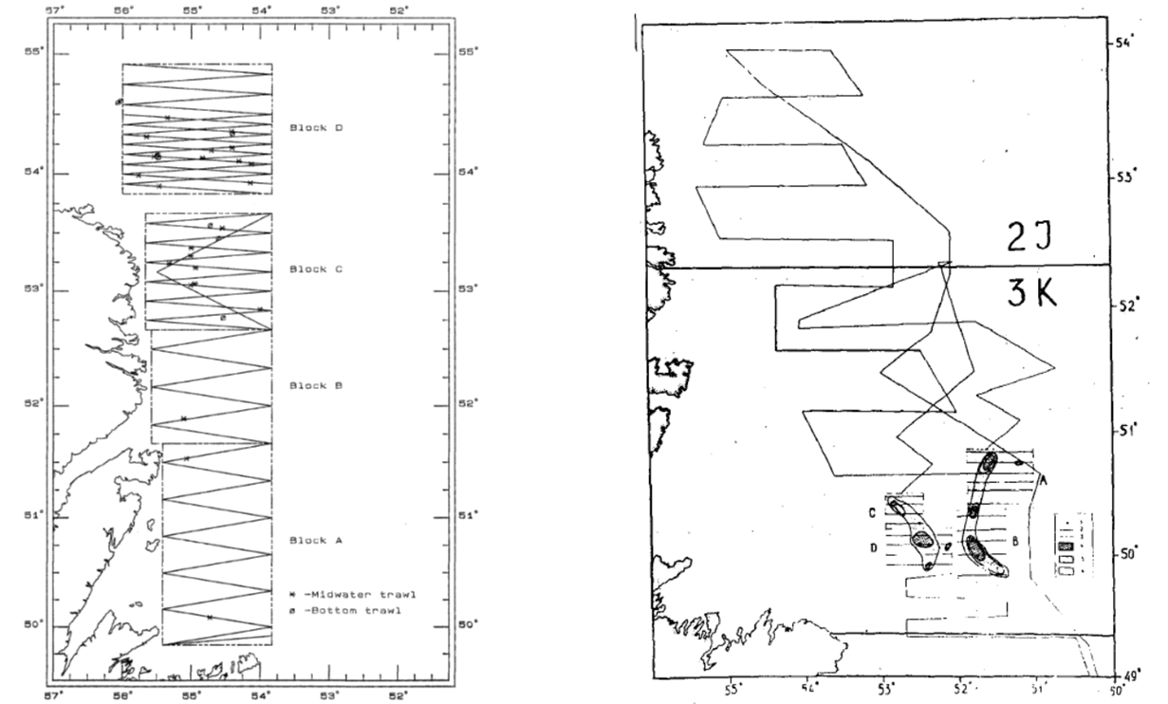

b

a

**Fig. 2**

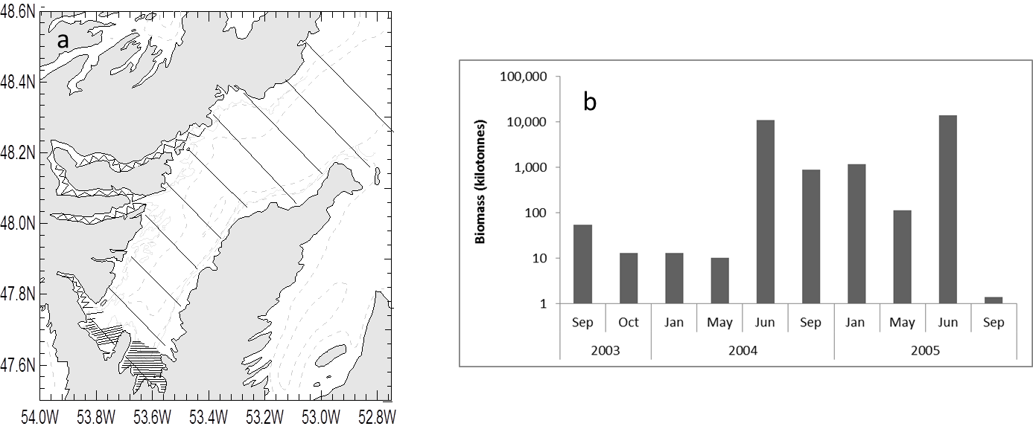

**Fig. 3 I want to remove October and only present 2003-2005**

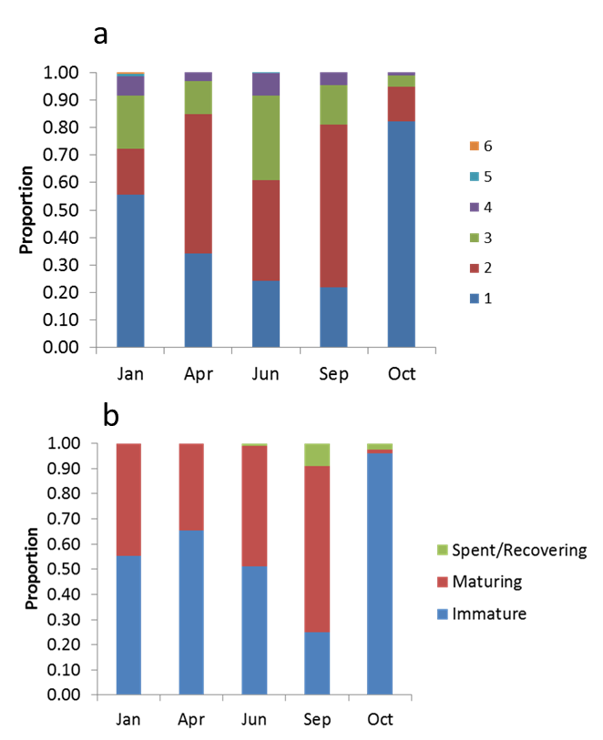

**Fig. 4**

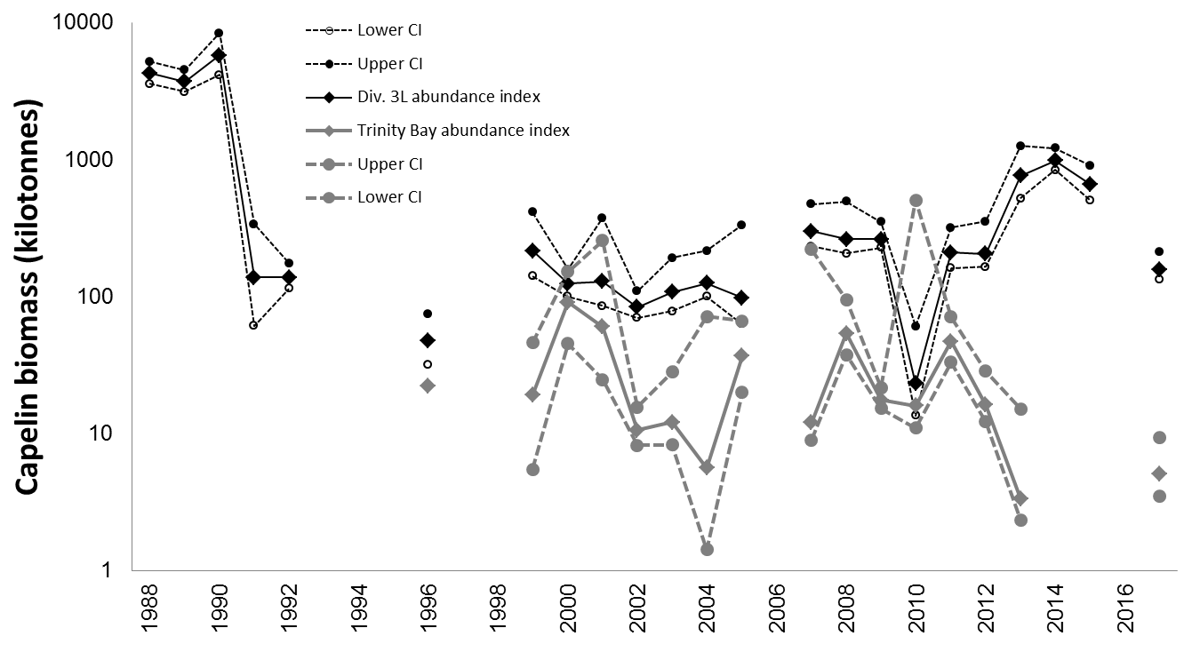

**Fig. 5**

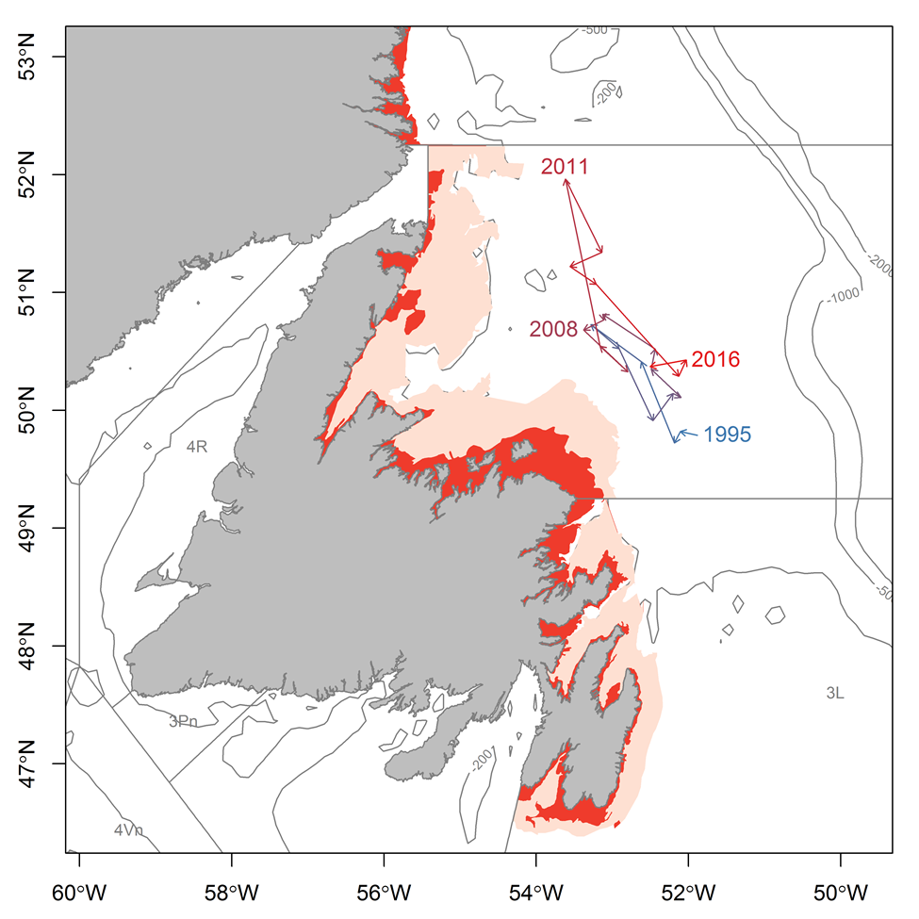

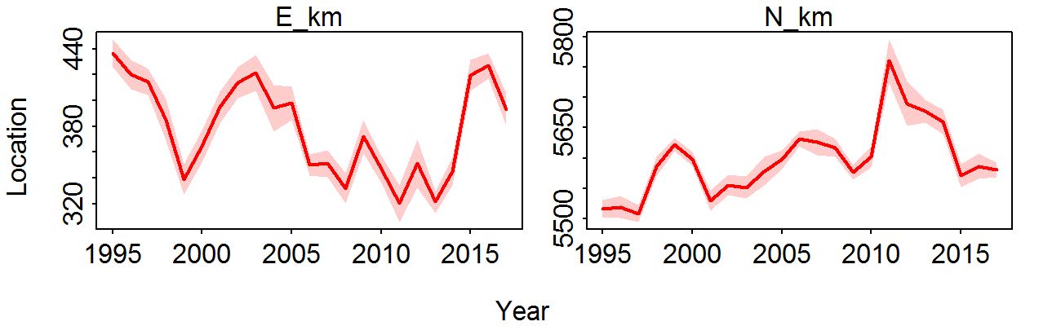

**Supplementary material**

**Trinity Bay seasonal inshore acoustic surveys (2003-2005)**

From 2002 another series of seasonal acoustic surveys (January, June and September) were conducted. (Table). Surveys were conducted from a 23 m inshore research vessel (CCGS Shamook) using a calibrated EK500 ecohosounder with a towed 38 kHz transducer. Surveys followed a fixed transect design and covered both the main portions and the four arms of Trinity Bay (Fig FM-6 ). When acoustic targets were encountered, sampling was conducted using bottom and midwater trawls, targeting the portion of the water column where the acoustic signal occurred. The lack of fishable aggregations of capelin precluded extensive sampling but samples were obtained from most aggregations. (Table ). Length, sex and maturity stage were recorded for all fish sampled and ages determined for two fish per sex per 0.5 cm interval.

Spatial patterns in age composition were similar to those patterns reported by Winters with older larger capelin overwintering in the main portion of the bay while juvenile capelin were more prevalent in the inner arms (Do we want maps?). In all months except June capelin were aggregated along the sides of the trench around 200 m depth, whereas in June they present in the arms and in shallower water closer to shore at the bottom of the bay.

In addition to occupations of Trinity Bay, Conception Bay (XXXX), Notre Dame Bay (1999) and Bonavista Bay (XXXX) have also been surveyed opportunistically during the offshore survey when time permitted. Although these occupations were not appropriate for the production of a biomass estimate, a variety of habitats within each Bay were investigated and no large densities of capelin observed.

(!!! INVALID CITATION !!! )

Anderson JT, Dalley EL, O'Driscoll RL (2002) Juvenile capelin (*Mallotus villosus*) off Newfoundland and Labrador in the 1990s. ICES Journal of Marine Science 59:917-928

Anon (1998) Capelin in SA2 + Div. 3KL. Book 98/63. Canadian Science Advisory Secretariat (CSAS) Research Document

Buren AD, Koen-Alonso M, Pepin P, Mowbray F, Nakashima BS, Stenson GB, Ollerhead N, Montevecchi WA (2014) Bottom-up regulation of capelin, a keystone forage species. PLoS ONE 9:e87589

Carscadden J, Nakashima BS, Miller DS (1994) An evaluation of trends in abundance of capelin (Mallotus villosus) from acoustics, aerial surveys and catch rates in NAFO Division 3L, 1982-89. Northw Atl Fish Sci 17:45-57

Carscadden JE, Gjøsæter H, Vilhjálmsson H (2013) A comparison of recent changes in distribution of capelin (*Mallotus villosus)* in the Barents Sea, around Iceland and in the Northwest Atlantic. Progress in Oceanography

Carscadden JE, Nakashima BS (1997) Abundance and changes in distribution, biology and behavior of capelin in response to cooler water of the 1990s. Forage fishes in marine ecosystems Proceedings of the International Symposium on the Role of Forage Fishes in Marine Ecosystems Alaska Sea Grant College Program Rep No AK-SG-97-01. University of Alaska Fairbanks, Fairbanks, Alaska

Dalley EL, Anderson JT, deYoung B (2002) Atmospheric forcing, larval drift, and recruitment of capelin ( Mallotus villosus ). ICES Journal of Marine Science 59:929-941

DFO (2008) Assessment of capelin in SA2+Div. 3KL in 2008. DFO Canadian Science Advisory Secretariat Science Advisory Report 2008/054

DFO (2010) Assessment of Capelin in SA 2 + Div. 3KL in 2010. DFO Canadian Science Advisory Secretariat Science Advisory Report 2010/090

DFO (2013) Assessment of capelin in SA2 + Div. 3KL in 2013. DFO Canadian Science Advisory Secretariat Science Advisory Report 2013/11

DFO (2015) Assessment of capelin in Subarea 2 and Divisions 3KL in 2015. DFO Canadian Science Advisory Secretariat Science Advisory Report 2015/036

Evans GT, Nakashima BS (2002) A weighted multiplicative analysis to estimate trends in year-class size of capelin. ICES Journal of Marine Science 59:1116-1119

Frank KT, Leggett WC (1982) Coastal water mass replacement: its effect on zooplankton dynamics and the predator–prey complex associated with larval capelin (*Mallotus villosus*). Canadian Journal of Fisheries and Aquatic Sciences 39:991-1003

Frank KT, Petrie B, Boyce D, Leggett WC (2016) Anomalous ecosystem dynamics following the apparent collapse of a keystone forage species. Marine Ecology Progress Series 553:185-202

Ingvaldsen RB, Gjøsæter H (2013) Responses in spatial distribution of Barents Sea capelin to changes in stock size, ocean temperature and ice cover. Marine Biology Research 9:867-877

Leggett WC, Frank KT, Carscadden JE (1984) Meteorological and hydrographic regulation of year-class strength in capelin (*Mallotus villosus*). Canadian Journal of Fisheries and Aquatic Sciences 41:1193-1201

McQuinn IH (2009) Pelagic fish outburst or suprabenthic habitat occupation: legacy of the Atlantic cod (*Gadus morhua*) collapse in eastern Canada. Canadian Journal of Fisheries and Aquatic Sciences 66:2256-2262

Melvin GD, Fife FJ, Sochasky JB, Power MJ, Stephenson RL (1995) The 1995 Update on Georges Bank 5Z Herring Stock. DFO Atlantic Fisheries Research Document 95/86

Miller DS (1994) Results from an acoustic survey for capelin (*Mallotus villosus*) in NAFO Divisions 2J3KL in the autumn of 1993. Capelin in SA2 + Div 3KL DFO Atlantic Fisheries Research Document 94/18

Miller DS (1997) Results from an acoustic survey for capelin (*Mallotus villosus*) in NAFO Divisions 3KL in the spring of 1996. Capelin in SA2 + Div 3KL DFO Atlantic Fisheries Research Document 97/29

Mowbray F (2002) Changes in the vertical distribution of capelin (*Mallotus villosus*) off Newfoundland. ICES Journal of Marine Science 59:942-949

Mowbray F (2014) Recent spring offshore acoustic survey results for capelin, *Mallotus villosus*, in NAFO Division 3L. DFO Canadian Science Advisory Secretariat Research Document 2013/040

Murphy HM, Pepin P, Robert D (2018) Re-visiting the drivers of capelin recruitment in Newfoundland since 1991. Fisheries Research 200:1-10

Nakashima B (1996) The relationship between oceanographic conditions in the 1990s and changes in spawning behaviour, growth and early life history of capelin (M*allotus villosus)*. NAFO Sci Coun Studies 24:55-68

Nakashima BS, Mowbray F (2014) Capelin (*Mallotus villosus)* recruitment indices in NAFO Division 3KL. DFO Canadian Science Advisory Secretariat Research Document 2013/091

Olafsdottir AH, Rose GA (2012) Influences of temperature, bathymetry and fronts on spawning migration routes of Icelandic capelin (*Mallotus villosus*). Fisheries Oceanography 21:182-198

Rose GA (1993) Cod spawning on a migration highway in the north-west Atlantic. Nature 366:458-461

Rose GA (2007) Cod: an ecological history of the North Atlantic fisheries. Breakwater Books, St John's, NL

Shuter BJ (1990) Population level indicators of stress. In: Adams SM (ed) Biological indicators of stress in fish. American Fisheries Society Symposium 8

Thorson J, T., Pinsky M, L., Ward E, J., Gimenez O (2016) Model‐based inference for estimating shifts in species distribution, area occupied and centre of gravity. Methods in Ecology and Evolution 7:990-1002

Thorson JT, Barnett LAK (2017) Comparing estimates of abundance trends and distribution shifts using single- and multispecies models of fishes and biogenic habitat. ICES Journal of Marine Science 74:1311-1321

Trippel EA (1995) Age at Maturity as a Stress Indicator in Fisheries: Biological processes related to reproduction in northwest Atlantic groundfish populations that have undergone declines. BioScience 45:759-771

Winters GH (1970) Biological changes in coastal capelin from the over-wintering to the spawning condition. Journal of the Fisheries Research Board of Canada 27:2215-2224